CURRICULUM VIATE

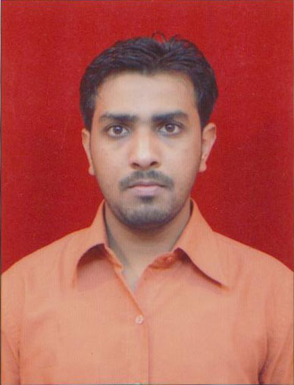
SUSHANT KUMAR
RZ-89A, Nand Ram Park
Uttam Nagar
New Delhi-110059
Contact No.: 9717780694
E-mail: - sushant.job86@gmail.com

CAREER OBJECTIVE

To achieve the best in hardest and difficult situation with passion and dedication. Always welcome the team to share success and growth. To seek challenging position in vibrant and dynamic organization where my abilities will utilize to fullest extent.

AREA OF MULTI-FACED STRENGTHS

+ General Administration Function + Canteen Management
+ MIS Reporting + Assets Management
+ Vendor Management + Board Meeting Arrangements
+ Housekeeping Management + Attendance Management
+ Security Management + Transport Management
+ Cooperation with All Departments + Visitor Welfare
+ Repair & Maintenance of All Office & Store + Travel Management
+ Government Tenders

EXPERIENCE

- Currently working with Scientific Security Management Services Pvt Ltd. as an Assistant Manager Administration.

- Worked with Impressions Services Pvt. Ltd. As an Admin executive From November 2009 To August 2011.

JOB PROFILE AND RESPONSIBILITIES FOR CURRENT ORGANIZATION

- Proficient in handling entire of general administration functions such Housekeeping, Security, Pest control, gardener, pantry boys, office boys and First AID box.
- Repair and Maintenance of all office & Stores.
- Manage office facilities and seating arrangements.
- Screening all Non- Trading vendor bills before processing & Tracking of vendor payment time to time.
- Provide Zonal Office stationery & General printing item (Visiting card, Letter head & envelop, name batch, I Card String).
- Purchase negotiation (Empanelment, Negotiation, finalization, Order issuance, delivery follow-ups).
- Maintaining office asset and taking care office equipment.
- Accommodation (Hotel & Guest booking) and Travel arrangement.
- Vendor management (Quality, Capability and Responsibility).
- Courier Incoming and outgoing.
- Network (Telephone line, Broadband and mobile connection) provide all Zonal & Regional office.
- Proper record on preparing monthly MIS for monthly expenditure in administrative activity.
- Proper filing and record keeping of expenses bill and other documents.
- Setting up of new offices/Guest Houses
- Coordinating with Architects if any Office Interiors changes to be done.
- Maintenance of Office cars/Booking of vehicles.
- AMC
- Board Meeting Arrangements
- Weekly Attendance Check for Security Guard & Runners.
- Managing administration to ensure effective delivery of services including housekeeping, hygiene management, Security, Cafeteria, Transport, Electricity, DG Sets, office equipment"s etc. to enable smooth day to day operations.
- Petty cash handling for purchasing of small items as well wears & tears
- Verifying Bill payments of Transport, Cafeteria, Pantry & housekeeping, electricity, diesel, Internet bills, security, DG sets and other office equipment"s to ensure their timely payment with coordination of the accounts department.
- Advance planning of the procurement of office equipment"s and other accessories/ consumables for the office use.
- Government Tenders
- Keep a track of insurance, vehicle maintenance, rent agreements
- Verification for Employees
- Exit Interview & FnF.
- Generation & issue of PF & ESIC number

EDUCATIONAL QUALIFICATION:-

- 10th Passed From C.B.S.E

- 12th Passed From N.I.O.S

- B.COM Pass

IT SKILLS

- Ms Office
- Tally 9 ERPs

SKILLS

- Ability to learn new skills with ease and work in a team.
- Good communication skill in Hindi and English.

SALARY DRAWN:

- 24,000/- P.M. and Other Benefits

EXPECTED SALARY : Negotiable

PERSONAL DETAILS:-

- Father’s Name : : Late Shri Surender Kumar
- Date of Birth : 18th December,1985
- Languages Known : English , Hindi
- Nationality : Indian
- Marital Status : Unmarried
- Personal Interest : To See Historical Places, Reading News
Paper & Playing Cricket.

Date ____________ (SUSHANT)
Place___________

